Catering Website

Name: SR Catering

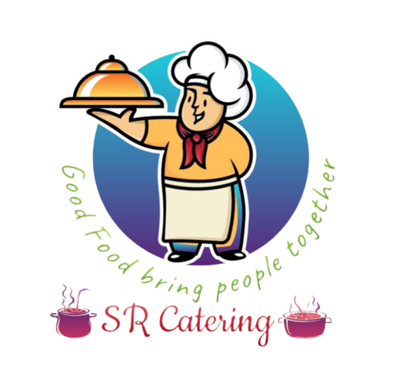

**Description:**

**What?--**

It is a Catering website. If User arranges the party or something related to this, they arrange the food on this website.

It is a fully ordered basis website.

**Why?--**

1.User will find the Catering service which gives

* Quality with 5 star rating
* On time
* Budget-friendly
* Professional chefs
* Event planning without wandering.

2.User didn’t have enough time to search the best catering during function mood

3.If User ordered ones, they don’t worry about that , we will be responsible till delivery.

**Features:**

1.Log-in:

2.Home :

* Why choose us
* Menu

3.About us:

* Our Branches
* Who we are
* What we do
* Our mission
* Our vision

4.Menu:

* Morning
* Mini
* Ordinary
* Special
* VIP
* Lunch
* Ordinary
* Special
* VIP
* High Tea (Evening snack)
* Ordinary
* Special
* VIP
* Dinner
* Ordinary
* Special
* VIP
* Custom Menu
* Depends upon the variety of dishes

5.Services:

* Birthday party
* Puberty Event
* Engagement
* Marriage
* Housewarming
* Valaikappu Event
* Private party (corporate,School, College,Industrial)

6.Contact Us:

* Our location
* Contact Details
* Feedback

7.Enquiry:

* Generate enquiry for what you want

In this website offer and discount available for User’s first booking, major orders

The total summary of order send to User’s both Whatsapp and Email

Both Vegetarian and Non-Vegetarian available.

Free delivery to around 20 km

Ordinary, Special and VIP menu available

All type of Payments available